**NAME: Mavia Alam Khan (2303.KHI.DEG.017)**

**PAIRING WITH: MUHAMMAD HUSSAM (2303.KHI.DEG.020)**

&

**Aqsa Tauheed (2303.KHI.DEG.011)**

**ASSIGNMENT 2.2**

Build a 6x4 matrix of random numbers.  
Using slicing, replace rows 5-6 of the matrix so that the  
5th row becomes a sum of the 1st and the 3rd row, and  
the 6th row becomes a sum of the 2nd and the 4th one.

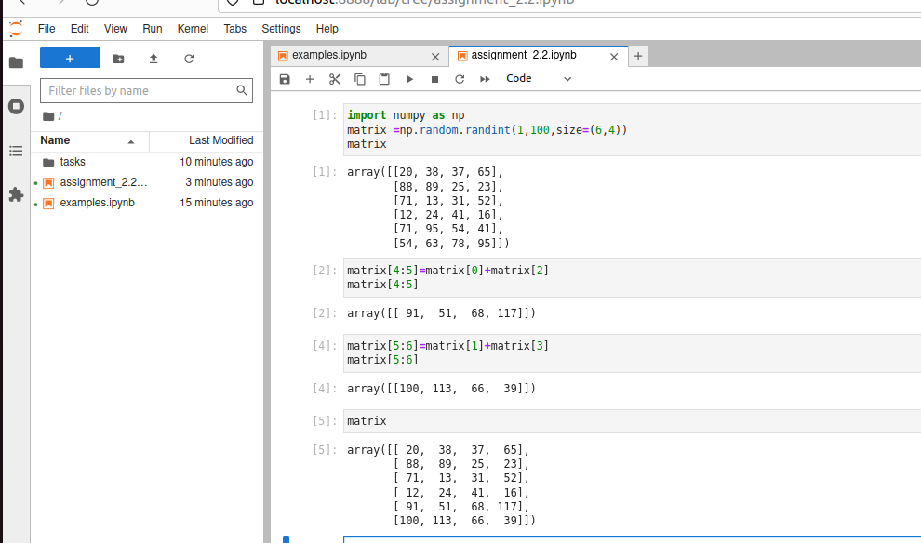

**EXPLANATION**

**Step 1:** we create a matrix of random number .it is 6 row and 4 column

**Step 2 :** we add row 0 and 2 into row 4 using slicing

**Step 3 :** we add row 1 and 3 into row 5using slicing

**Step 4** : finally we update the row 5 and 6